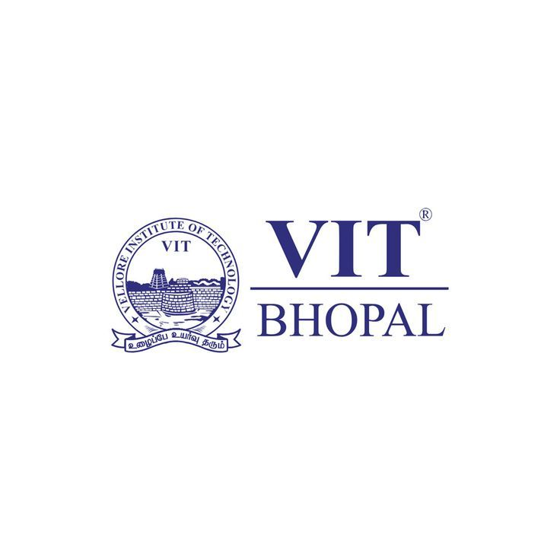

DIGITAL LITERACY
PROJECT REPORT

NAME: S. EVANJALIN SUJITHA
REG NO: 25BHI10029
COURSE: B. TECH CSE HEALTH INFORMATICS
YEAR: 2025-2029
COURSE CODE: CSE0001
DATE: 30TH MARCH 2026
INTRODUCTION:
This project focuses on developing digital literacy skills through a series of practical and real-world tasks. It includes activities such as writing professional emails, practising coding on online platforms, creating Google Forms for collaboration, and understanding cybercrime and online safety. The project is designed around the role of a Digital Ambassador, where students learn how to guide others in using digital tools effectively.
Through these tasks, students gain hands-on experience with important platforms and improve their communication, technical, and analytical skills. The project also emphasizes responsible online behavior, including safe internet practices and awareness of cyber threats. Overall, it helps students become more confident and responsible digital users, which is essential for academic success and future career growth.

Task 1: Digital Literacy Awareness Infographic
📄 Project Report:
For this task, I used Canva to design my infographic because it is simple to use and offers many templates and design elements. The tool helped me create a visually appealing and well-organized slide without needing advanced design skills.
My infographic covers three main topics: digital literacy, useful digital tools for students, and professional online presence. It explains digital literacy as the ability to use digital devices and platforms effectively for learning and communication. I included examples of tools such as Google Docs and online learning platforms that help students collaborate and improve productivity. I also added important safety tips like using strong passwords, avoiding suspicious links, and protecting personal information online.
While creating the design, I found it interesting to combine text and visuals in a creative way. However, one difficulty I faced was selecting the right layout and keeping the content simple without making the design look crowded. This task helped me improve both my creativity and understanding of digital tools.

Task 2: Build Your Student Digital Portfolio
📄 Project Report:
For building my professional online presence, I chose platforms like LinkedIn, GitHub, and Kaggle. Each of these platforms serves a different purpose and helps in career development.
LinkedIn is mainly used for professional networking, where I can connect with industry experts, showcase my skills, and stay updated with job opportunities. GitHub is useful for sharing and managing my coding projects, which helps in building a strong portfolio for technical roles. Kaggle is a platform for practicing data science and machine learning skills through datasets and competitions.
Over the next four years, I plan to regularly update my LinkedIn profile with achievements, internships, and certifications. On GitHub, I will upload my academic and personal projects to demonstrate my coding abilities. On Kaggle, I aim to participate in competitions and improve my analytical skills. By consistently using these platforms, I hope to build a strong professional profile and improve my career opportunities.

Task 3: Explore Coding & Collaboration Platforms
📄 Project Report:
For this task, I explored both coding and collaboration platforms to improve my digital skills. I created an account on HackerRank and completed a beginner-level challenge called “Solve Me First.” This helped me understand basic problem-solving logic and how to write simple programs in a structured way. Practising on such platforms is useful for improving coding skills and preparing for technical interviews.
For collaboration, I used Google Forms to create a “Digital Literacy Awareness Quiz” with five questions, including multiple-choice and short-answer types. The responses were automatically collected and organized in Google Sheets, making it easy to analyze data.
These tools will help me academically by improving my coding ability, logical thinking, and data handling skills. Coding platforms allow me to practise regularly, while Google Workspace tools help in conducting surveys, managing data, and collaborating with others. Overall, this task enhanced my practical knowledge and will support my learning throughout my academic journey.
Task 4: Draft a Professional Email & Etiquette Guide
📄 Project Report:
In this task, I learned about professional email etiquette and responsible social media use. I wrote two formal emails—one requesting an assignment extension and another expressing interest in a summer internship. This helped me understand the importance of clear subject lines, polite language, and proper sign-offs in professional communication.
I also created a social media Do’s and Don’ts checklist to promote safe and responsible online behavior among college students.
A situation where poor digital communication caused a problem could be when a student posted an inappropriate comment about a professor on social media. The post was misinterpreted and spread quickly, leading to disciplinary action. This could have been avoided by thinking before posting, using respectful language, and choosing a private method to express concerns. This task improved my awareness of effective and responsible digital communication.

Task 5: Cybercrime Awareness Case Study & Prevention Guide
📄 Project Report:
While researching cybercrime, I was most surprised by how easily people fall victim to identity theft and online payment fraud. Many attacks do not involve complex hacking but instead rely on simple tricks like fake messages, phishing links, or social engineering. I realized that even basic mistakes, such as sharing personal information or clicking unknown links, can lead to serious consequences like financial loss and privacy breaches.
This task made me more aware of the importance of online safety and responsible digital behavior. One habit I will personally change is being more cautious before clicking any link or sharing sensitive information online. I will also make sure to verify sources, use strong passwords, and enable two-factor authentication for my accounts. Overall, this activity helped me understand that awareness and small precautions can greatly reduce the risk of cybercrime.
CONCLUSION:
This project helped me develop a strong understanding of digital literacy and its importance in daily academic life. I learned how to write professional emails, use coding platforms, and create online forms for collaboration. It also improved my awareness of cybercrime and safe internet practices. Through hands-on activities, I gained confidence in using digital tools effectively and responsibly. I understood the importance of maintaining a professional online presence and protecting personal information. Overall, this project enhanced my technical, communication, and critical thinking skills, preparing me to use technology efficiently for both academic and future professional purposes.
References:
- HackerRank – For coding practice and problem-solving
- HackerEarth – For beginner coding challenges
- Google Forms – For creating quizzes and collecting responses
- Google Sheets – For storing and analyzing form responses
- Canva – For designing infographic/presentation
- National Cyber Crime Portal (https://www.cybercrime.gov.in) – For cybercrime awareness and reporting
- General knowledge and academic materials on digital literacy and cyber safety

